**ASSIGNMENT 4:**

**package** cross1;

**import** java.util.concurrent.TimeUnit;

**import** junit.framework.~~Assert~~;

**import** org.openqa.selenium.By;

**import** org.openqa.selenium.WebDriver;

**import** org.openqa.selenium.WebElement;

**import** org.openqa.selenium.chrome.ChromeDriver;

**import** org.openqa.selenium.edge.EdgeDriver;

**import** org.openqa.selenium.firefox.FirefoxDriver;

**import** org.openqa.selenium.ie.InternetExplorerDriver;

**import** org.testng.annotations.BeforeTest;

**import** org.testng.annotations.Optional;

**import** org.testng.annotations.Parameters;

**import** org.testng.annotations.Test;

**public** **class** Cc {

WebDriver driver;

@BeforeTest

@Parameters("browser")

**public** **void** setup(String browser) **throws** Exception{

//Check if parameter passed from TestNG is 'firefox'

**if**(browser.equalsIgnoreCase("chrome")){

//create firefox instance

System.*setProperty*("webdriver.chrome.driver","C:\\Program Files\\Java\\jdk1.8.0_131\\chromedriver.exe");

driver= **new** ChromeDriver();

driver.get("http://google.com") ;

}

//Check if parameter passed as 'chrome'

**else** **if**(browser.equalsIgnoreCase("ie")){

//set path to chromedriver.exe

System.*setProperty*("webdriver.ie.driver","C:\\Program Files\\Java\\jdk1.8.0_131\\IEDriverServer.exe");

driver = **new** InternetExplorerDriver();

driver.get("http://google.com") ;

}

//Check if parameter passed as 'Edge'

**else** **if**(browser.equalsIgnoreCase("Edge")){

//set path to Edge.exe

System.*setProperty*("webdriver.edge.driver",".\\MicrosoftWebDriver.exe");

//create Edge instance

driver = **new** EdgeDriver();

}

**else**{

//If no browser passed throw exception

**throw** **new** Exception("Browser is not correct");

}

driver.manage().timeouts().implicitlyWait(10, TimeUnit.***SECONDS***);

}

@SuppressWarnings("deprecation")

@Test

@Parameters({"author","searchKey"})

**public** **void** testParameterWithXML( @Optional("Abc") String author,String searchKey) **throws** InterruptedException{

WebElement searchText = driver.findElement(By.*name*("q"));

//Searching text in google text box

searchText.sendKeys(searchKey);

System.***out***.println("Welcome ->"+author+" Your search key is->"+searchKey);

Thread.*sleep*(3000);

System.***out***.println("Value in Google Search Box = "+searchText.getAttribute("value") +"::: Value given by input = "+searchKey);

~~Assert~~.*assertTrue*(searchText.getAttribute("value").equalsIgnoreCase(searchKey));

}}

**XML CODE:**

<?xml version="1.0" encoding="UTF-8"?>

<!DOCTYPE suite SYSTEM "http://testng.org/testng-1.0.dtd">

<suite name="TestSuite" thread-count="2" parallel="tests" >

<test name="ChromeTest">

<parameter name="browser" value="chrome" />

<parameter name="browser" value="ie" />

<parameter name="author" value=" Mary" />

<parameter name="searchKey" value=" Pleasanton" />

<classes>

<class name="cross1.Cc">

</class></classes>

</test></suite>

**OUTPUT:**

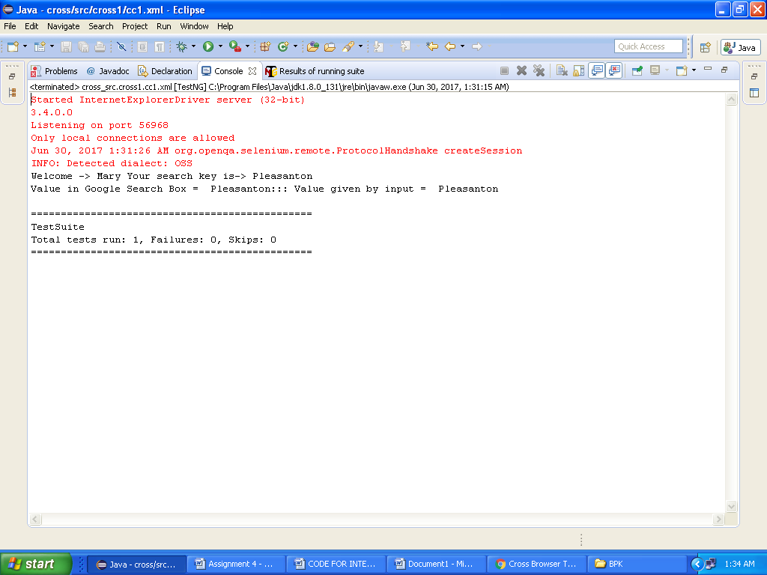

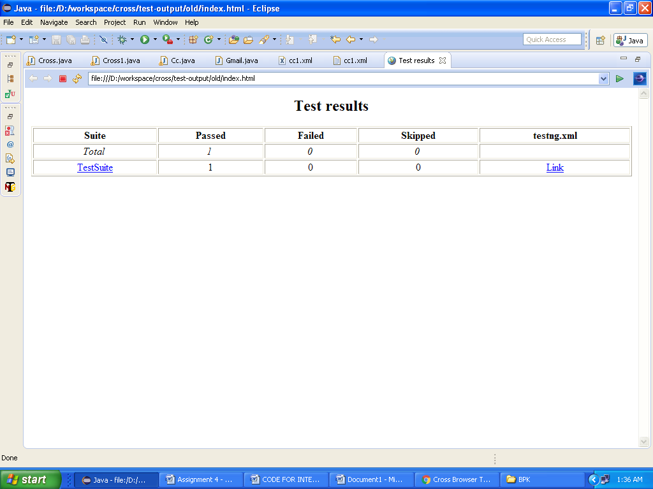

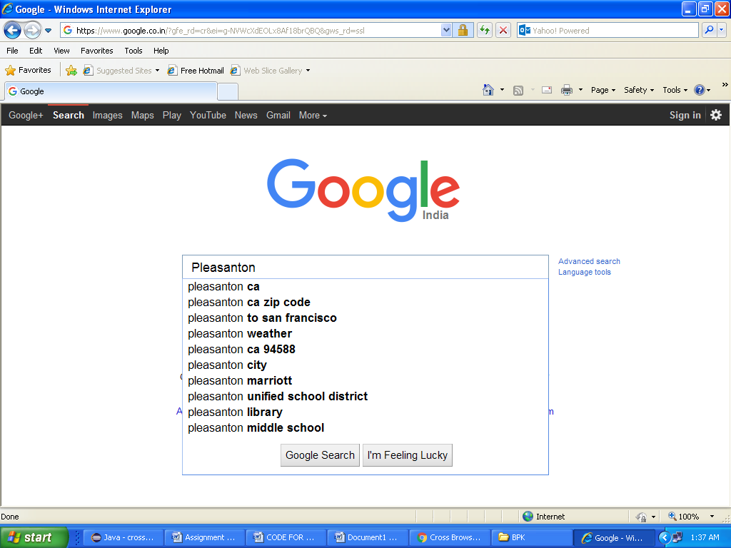

SC1.IE BROWSER

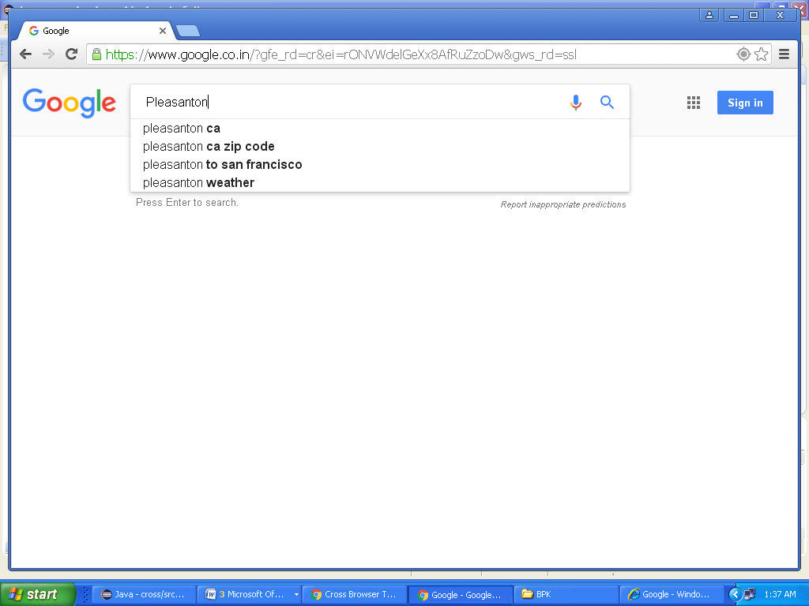

SC2.CHROME BROWSER

**ASSIGNMENT 5**

package cross1;

import static org.testng.AssertJUnit.assertEquals;

import org.openqa.selenium.WebDriver;

import org.openqa.selenium.chrome.ChromeDriver;

import org.testng.annotations.Test;

public class Assertion {

@Test

public void f() {

WebDriver driver;

System.setProperty("webdriver.chrome.driver","C:\\Program Files\\Java\\jdk1.8.0_131\\chromedriver.exe");

driver= new ChromeDriver();

driver.get("http:// techfetch.com") ;

Assertion.assertEquals("techfetch", driver.getTitle());}

private static void assertEquals(String string, String title) {

// TODO Auto-generated method stub

}

}

**OUTPUT:**

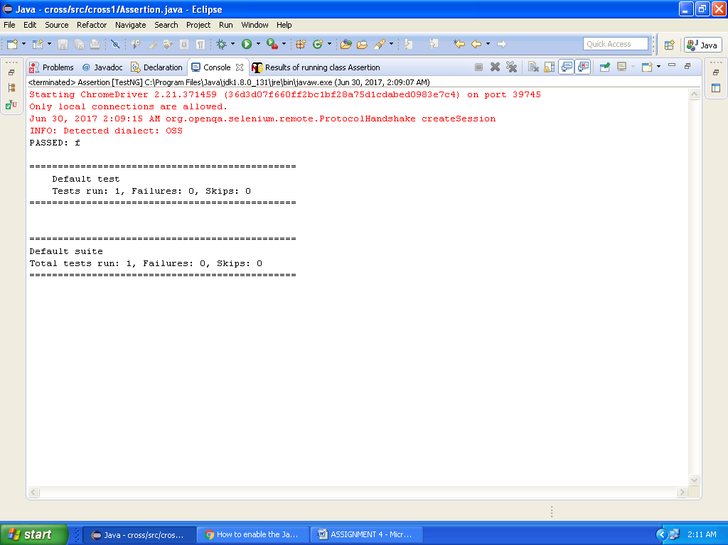

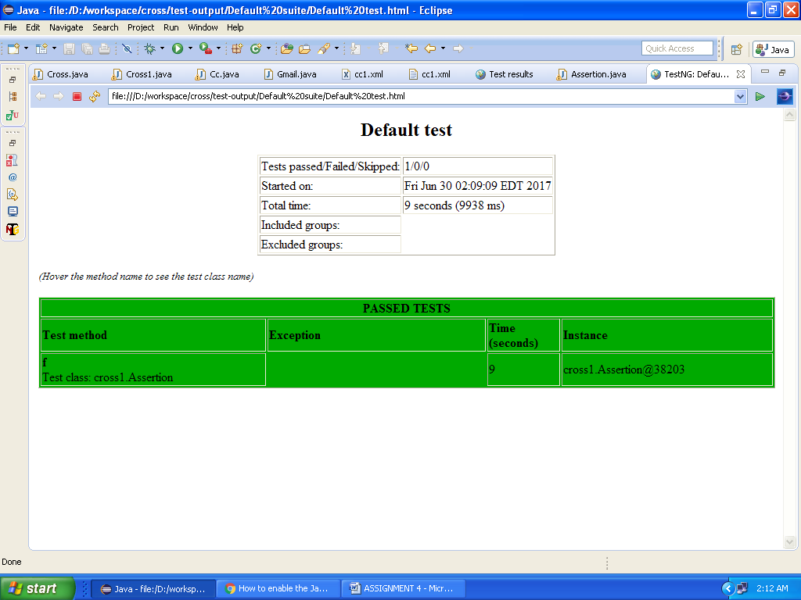

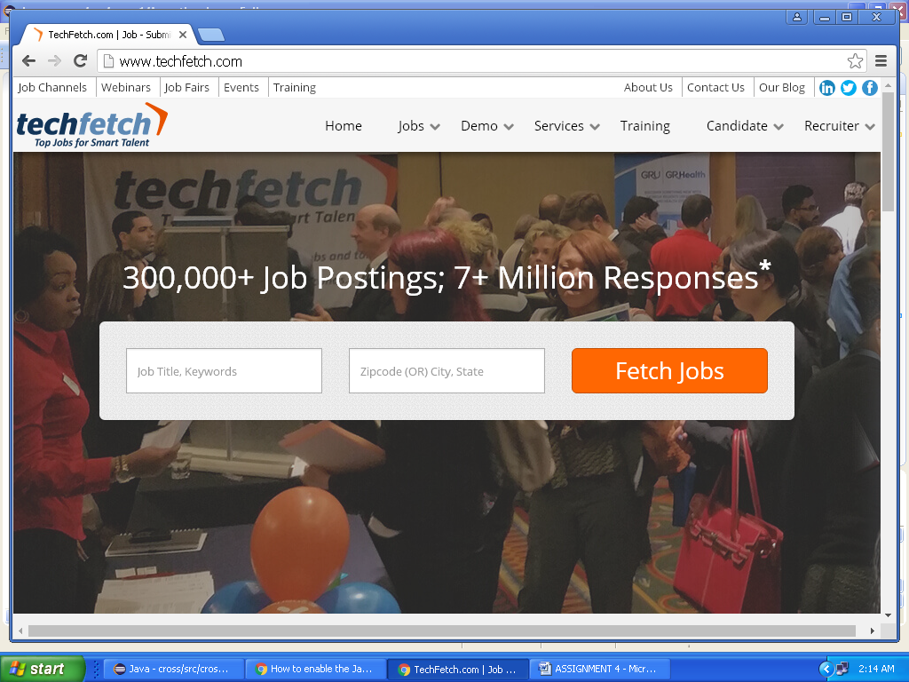

Screenshot.techfetch